190905513 LAB 02 MOHAMMAD DANISH EQBAL

BATCH A3 PRELIMINARY SCANNING APPLICATIONS SECTION A

SAMPLE EXERCISE:

Program to remove single and multiline comments from a given ‘C’ file.

Program:
//Program to remove single and multiline comments from a given ‘C’ file.
#include <stdio.h>
#include <stdlib.h>
int main()
{
FILE *fa, *fb;
int ca, cb;
fa = fopen("in.c", "r");
if (fa == NULL){
printf("Cannot open file \n");
exit(0); }
fb = fopen("out.c", "w");
ca = getc(fa);
while (ca != EOF)
{
if(ca==' ')
{
putc(ca,fb);
while(ca==' ')
ca = getc(fa);
}
if (ca=='/')
{
cb = getc(fa);
if (cb == '/')
{
while(ca != '\n')
ca = getc(fa);
}
else if (cb == '*')
{
do
{
while(ca != '*')
ca = getc(fa);
ca = getc(fa);
} while (ca != '/');
}
else
{
putc(ca,fb);
putc(cb,fb);
}
}
else putc(ca,fb);
ca = getc(fa);
}
fclose(fa);
fclose(fb);
return 0;
}

Output:

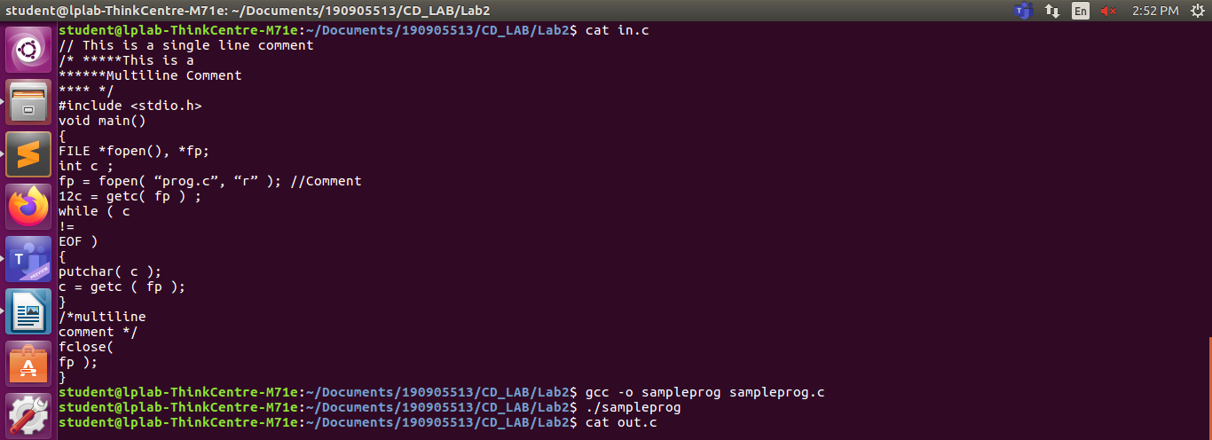

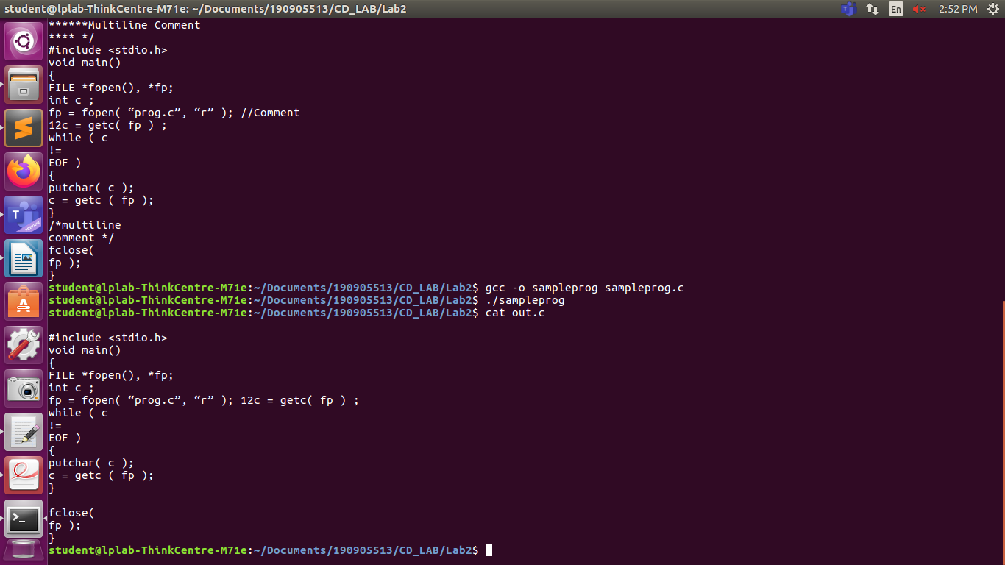

LAB EXERCISES:

Write a ‘C’ program

1. That takes a file as input and replaces blank spaces and tabs by single space and writes the output to a file.

Program:

/*Program that takes a file as input and replaces blank spaces and tabs by single space and writes the output to a file.*/
#include <stdio.h>
#include <string.h>
#include <unistd.h>
#include <stdlib.h>

int main()
{
int flag=0;
char c;
FILE *f1,*f2;
f1 = fopen("sin.c", "r");
f2 = fopen("sout.c", "w");

if(f1 == NULL || f2 == NULL)
{
perror("Files missing..\n");
return 1;
}

while(1)
{
c = fgetc(f1);

if(c==EOF)
{
break;
}

else if(!flag && (c==' '||c=='\t'))
{
fputc(' ', f2);
flag = 1;
}

else if(!(c==' '||c=='\t'))
{
flag = 0;
fputc(c, f2);
}
}

fclose(f1);
fclose(f2);
}

Output:
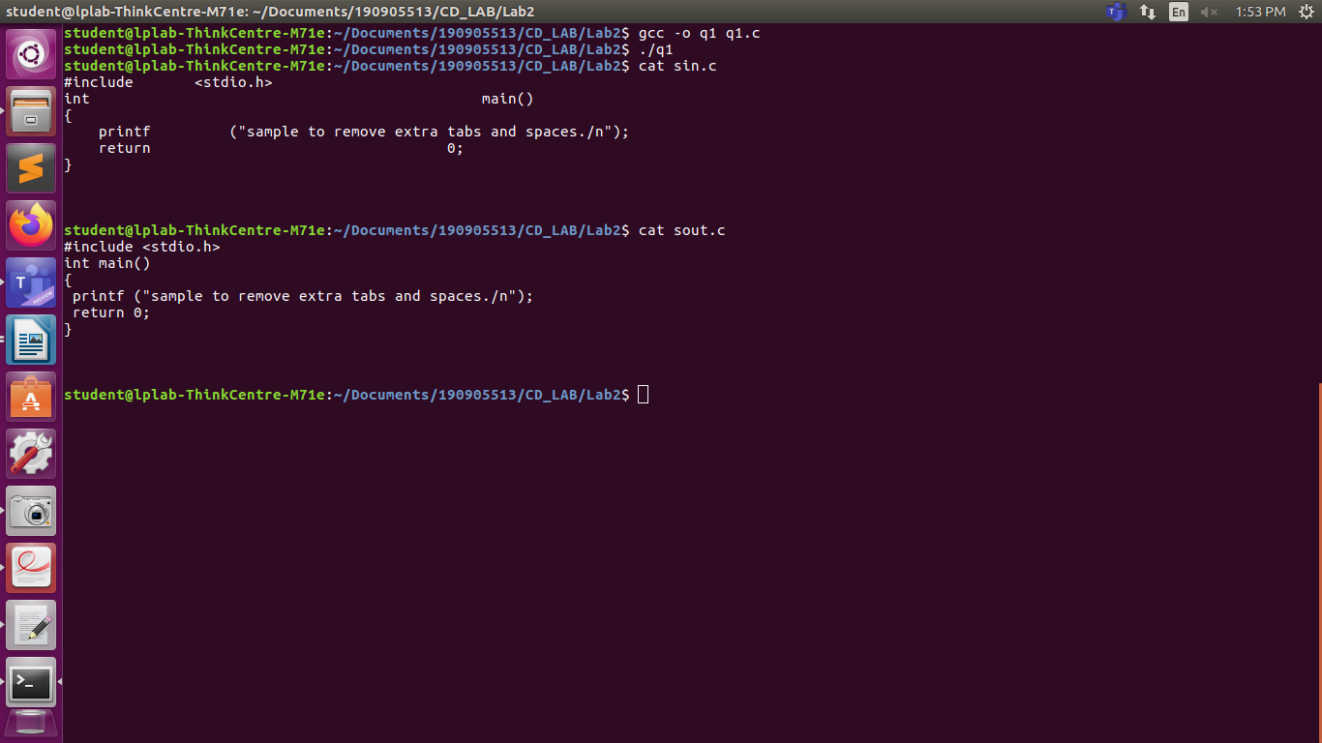

2. To discard preprocessor directives from the given input ‘C’ file.

Program:

/*Program to discard preprocessor directives from the given input ‘C’ file.*/
#include <stdio.h>
#include <string.h>
#include <unistd.h>
#include <stdlib.h>
#define FILEINPUT "sampin.c"
#define FILEOUTPUT "sampout.c"

const char *direct[] = {"#include","#define","#if"};

int is_directive(const char *str)
{
for(int i = 0; i < sizeof(direct)/sizeof(char *); i++)
{
int len = strlen(direct[i]);

if(strncmp(str, direct[i], len) == 0)
{
return 1;
}
}

return 0;
}
int main()
{
char buf[2048];
FILE *f1,*f2;

f1 = fopen(FILEINPUT, "r");
f2 = fopen(FILEOUTPUT, "w");

if(f1 == NULL || f2 == NULL)
{
perror("Files are missing..\n");
return 1;
}

while(fgets(buf, 2048, f1) != NULL)
{
if(!is_directive(buf))
{
fputs(buf, f2);
}
}

fclose(f1);
fclose(f2);
f1= fopen(FILEINPUT,"w");
f2=fopen(FILEOUTPUT,"r");
char copy;
copy=getc(f2);

while(copy!=EOF)
{
putc(copy,f1);
copy=getc(f2);
}

fclose(f1);
fclose(f2);

}

Output:

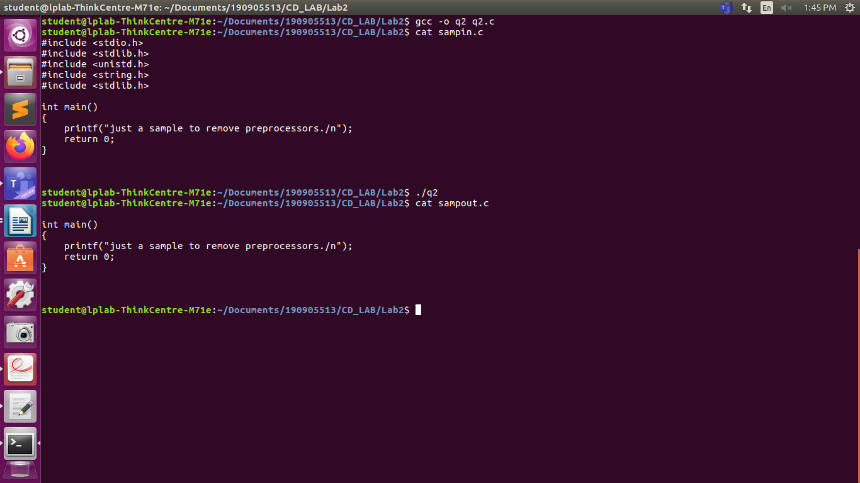

3. That takes C program as input, recognizes all the keywords and prints them in upper case.

Program:

/*Program that takes C program as input, recognizes all the keywords and prints them in upper case.*/
#include <stdio.h>
#include <string.h>
#include <stdlib.h>
#include <ctype.h>
#include <stddef.h>

const char *keywords[15] = {
"void","do","if","int","struct","break","else","switch",
"case","return","for","static","while","default","float"
};

const char delimiters[]=" .,;:!-()\n\t";

int isKeyword (char *word) {
int i;
for (i = 0; i < 32; ++i) {
if (strcmp(word, keywords[i]) == 0) {
return 1;
}
}
return 0;
}

void printUpperCase (char *word) {
int l = strlen(word);
char z;
int i;
for (i = 0; i < l; ++i) {
z = word[i];
printf("%c", z > 96 ? z - 32 : z);
}
printf("\n");
}

int main(int argc ,char **argv){

FILE *fd1;

fd1=fopen(argv[1],"r");
printf("Keywords from the above program are converted to the uppercase:\n");
if(fd1==NULL){
printf("Cannot open the file to read...\n");
exit(0);
}
char buffer[1024];
while(fgets(buffer,1024,fd1) >0){
//temp copy of string
char *cp =(char*)malloc(1024*sizeof(char));
strcpy(cp,buffer);

char *token=(char*)malloc(256*sizeof(char));
do {
token =strsep(&cp,delimiters);
if(token!=NULL)
{
if(isKeyword(token)){

printUpperCase(token);
}
}
}while(token!=NULL);
}

fclose(fd1);
return 0;
}

Output:

